Game Lore and Worldbuilding
Fractured Stars: Tau Ceti Beltfall

Overview:
Year: 3458. Humanity has expanded far beyond the Solar System but brought its old flaws with it. Star systems have become battlegrounds for clashing visions of the future. In the asteroid belt of the Tau Ceti system, rival factions fight for dominance, survival, and ideology. You are a pilot assigned to secure the asteroid fields, tasked with shooting down all enemy ships to secure your faction's future.
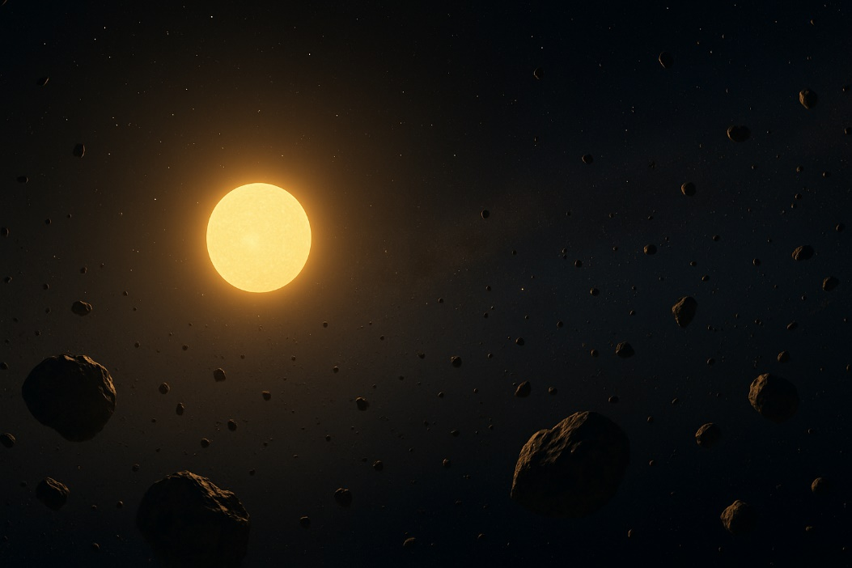
Gameplay: Multiplayer ship combat in dense asteroid belts. Players choose a faction and fight for control of the Tau Ceti system.

Setting: Tau Ceti System
- Star: Tau Ceti (real star system ~12 light-years from Earth).
- Key Features:
  - Sun-like G-type star.
  - Five known terrestrial planets (candidates like Tau Ceti e, f).
  - Massive debris disk (asteroid belt) detected.
- Strategic Importance: Rich in minerals, water, and fusion elements critical for ships and colonies.

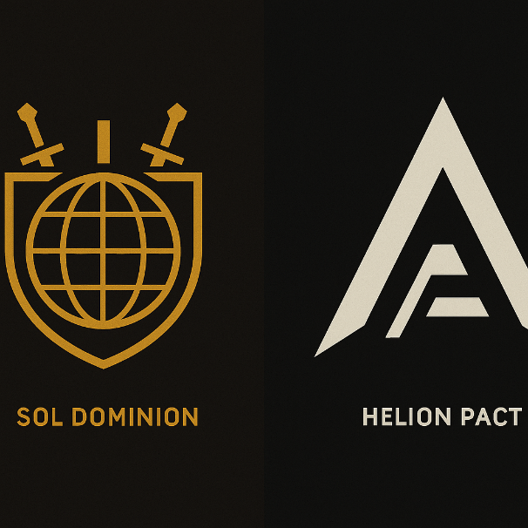
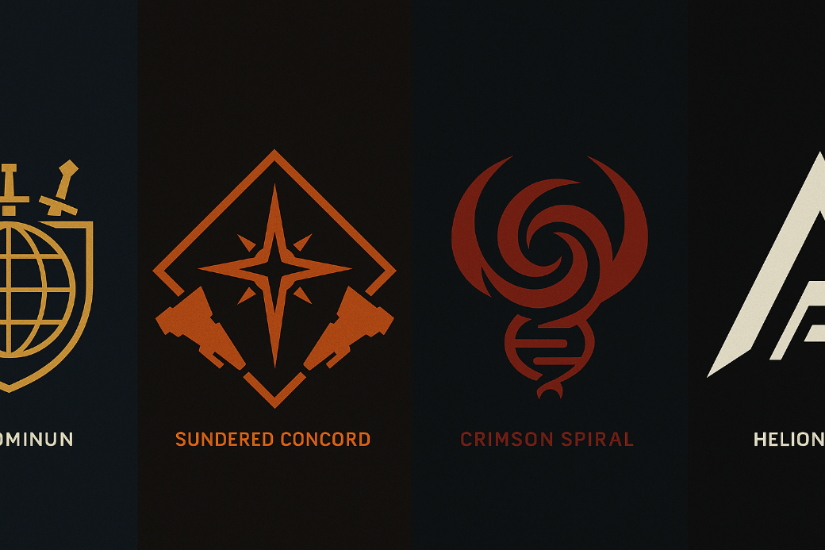
Factions:
- Sol Dominion
  - Ideology: Technocratic Nationalism
  - Goal: Bring Tau Ceti under centralized Earth control.
  - Visuals: Heavy, blocky ships; navy blues, steel grey, gold insignias.
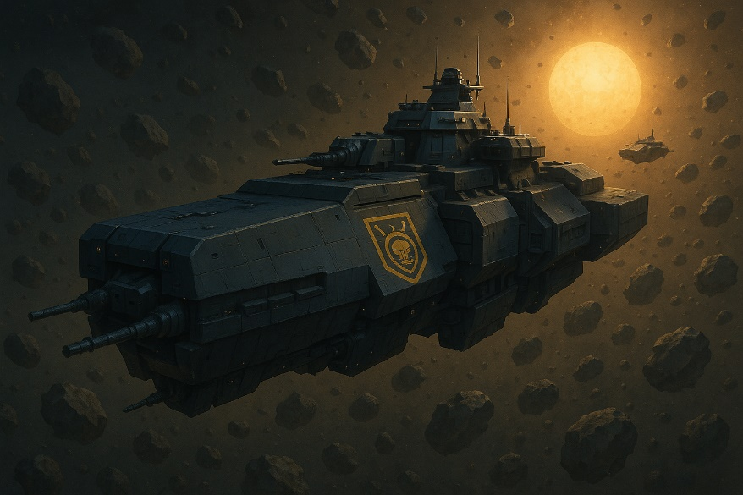
  - Style: Brutalist, monolithic warships.
- The Sundered Concord
  - Ideology: Libertarian Separatism
  - Goal: Preserve personal freedom; resist any centralized power.
  - Visuals: Scrappy, asymmetric, modular ships; rusty reds, dusty yellows.
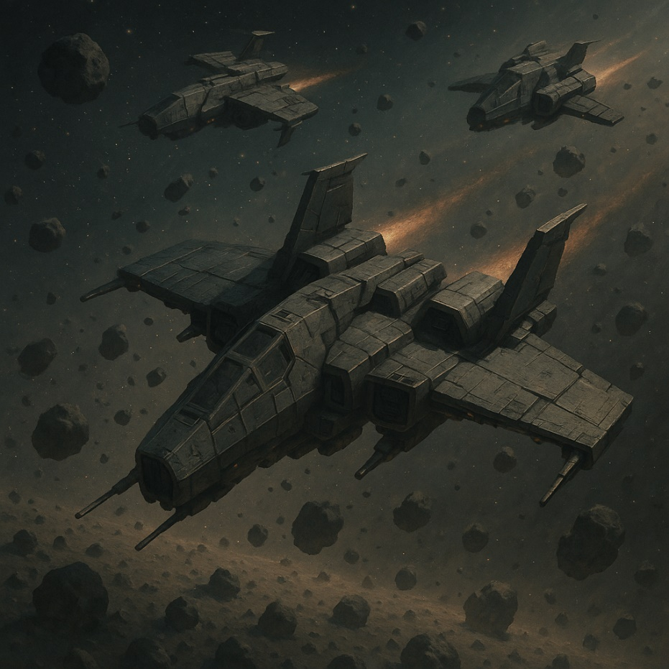
  - Style: Frontier survivalists, "space cowboys" with patched-together ships.
- The Crimson Spiral
  - Ideology: Eco-Technotheocracy
  - Goal: Engineer a new evolution by merging life and machine.
  - Visuals: Organic, biomechanical ships; glowing reds, purples, greens.
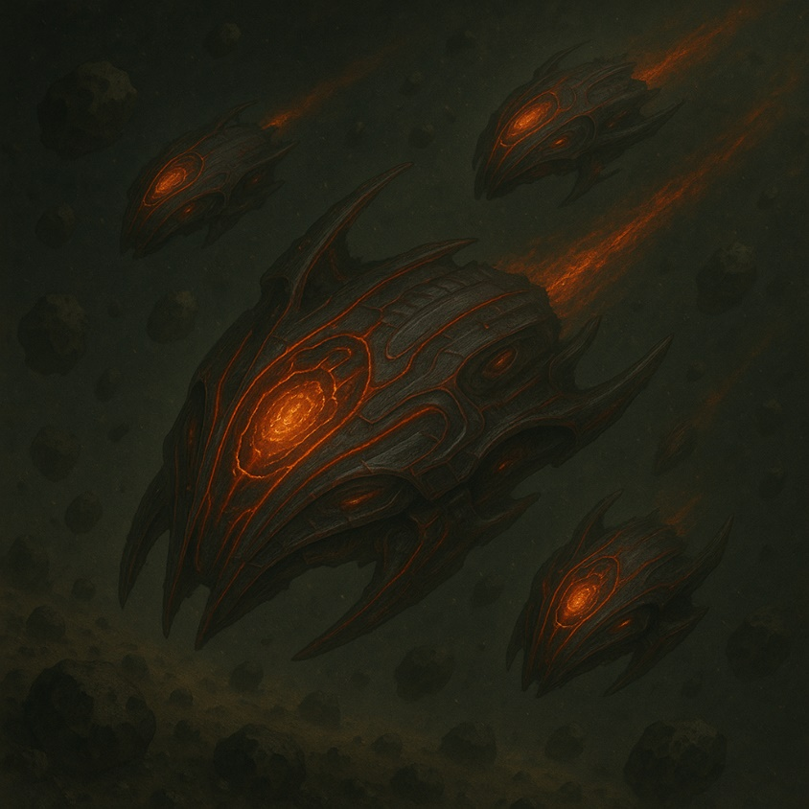
  - Style: Coral-like, living ships with pulsating lights and tendrils.
- Helion Pact
  - Ideology: Corporate Syndicalism
  - Goal: Control Tau Ceti's resources for mega-corporate wealth.
  - Visuals: Sleek, angular ships; black and chrome with neon logos.
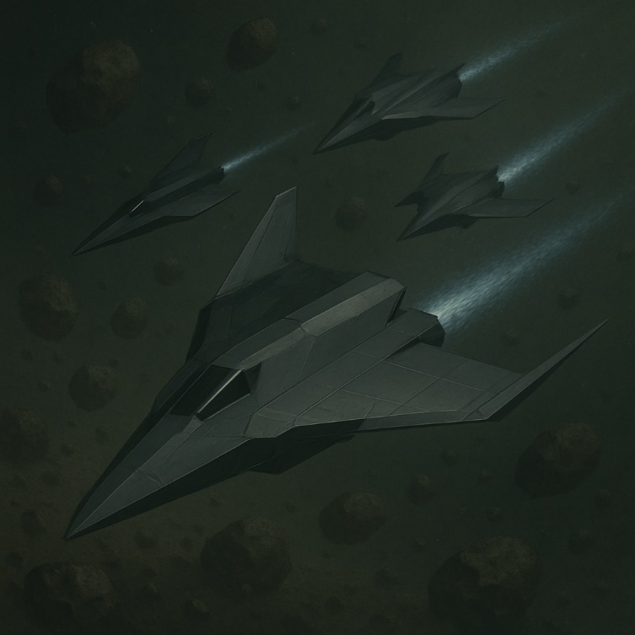
  - Style: Corporate stealth bombers, clean and efficient.

Why the Asteroid Belt Matters:
- Mineral-rich (metals, exotic elements).
- Hidden pre-human artifacts (rumored by Crimson Spiral).
- Control of the belt = economic and military supremacy.

Starter Ships (Concepts):
Faction | Ship Name | Class | Description
Sol Dominion | Vindicator Mk. VII | Heavy Fighter | Armored, slow, powerful twin railguns.
Sundered Concord | Wildcat | Light Skirmisher | Fast, fragile, heavily armed with missiles.
Crimson Spiral | Whisper of Flesh | Adaptive Cruiser | Semi-organic, plasma weaponry, regenerates hull slowly.
Helion Pact | Zyrex Lancer | Interceptor | High-speed, stealthy beam ship.

Summary Description:
Fractured Stars: Tau Ceti Beltfall— It’s 3458. Humanity’s future is fought not on planets, but in the treacherous asteroid belts of distant suns. Choose your faction. Secure the belt. Defend your future — or take it by force.

Title Screen: [hold ]
[somber swelling music]
Tau Ceti Asteroid Belt [fade in]
3458 AD [fade in under]

[fade in]
Humanity has taken to the stars and with them their vicious appetites for resources and power. Amongst the Tau Ceti solar system 12 light years from earth tensions grow amongst factions each with different views for unification.
[fade out]
The mineral rich asteroid belt holds the key for power. The faction that controls the belt controls the solar system. Secure the belt to defend your future
